**Khandesh College Education Society’s**

**COLLEGE OF ENGINEERING AND MANAGEMENT, JALGAON**

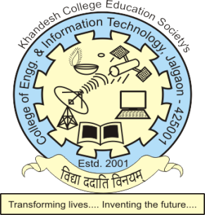

An On Job Training Report

On

**“QA Engineer”**

**(SSC QP CODE: 1302)**

At

**KCE Society’s College of Engineering and Management, Jalgaon**

Submitted By

SUJIT CHHOTU ADHAV

DBATU ENROLLEMENT NO.: 1951065112012

Of

S.E. (Bachelor of Vocation in Software Development)

Under Supervision of

Mr. Shashikant Karulkar

Semester – IV

Yr. 2021 - 22

**As per syllabus of**

**NASSCOM Sector Skill Council and AICTE, New Delhi**

**CERTIFICATE**

This is to certify that the “**OJT Report”** submitted by **Sujit Chhotu Adhav (DBATU PRN NO: 1951065112012)** is work done by him/her and submitted during academic year 2021-22, Semester – IV in partial fulfillment of the requirements for the award of the degree of **Bachelor of Vocation in Software Development**

**Department Head Training Officer**

**Mr. Yogesh Fengade Mr. Sachin Sonawane**

**Dr. K. P. Rane**

**Principal**

KCE Society’s

College of Engineering and Management

**ACKNOWLEDGEMENT**

## First, I would like to thank Prof. Dr. K. P. Rane, the Principal of KCES’ COEIT, Jalgaon&Prof. S. P. Pawde, Director, KCES’ DKSDCfor giving me the opportunity to do an OJT online from KCE’s College of Engineering and Management, Jalgaon, from to 05-10-2021 to 14-10-2021 duration.

* I also would like to thank all the faculty mentors of company / training organization of KCE’s College of Engineering and Management, Jalgaon who guided and mentored me with their expertise, patience and openness and they have created an enjoyable working environment.
* It is indeed with a great sense of pleasure and immense sense of gratitude that I acknowledge the help of these individuals.
* I would like to thank Prof. Shashikant Karulkar**,** College OJT Coordinator faculty member for their support and advices to get and complete OJT in above said organization.
* I am extremely great full to my department staff members and friends who helped me in successful completion of this OJT.

Sujit Chhotu Adhav